THEORY ASSIGNMENT NO.1

Name-Vinaya Vasant Chaudhari

Roll no- CS6-10

PRN-202401100119

Batch-CS61

Que) Formulate 20 problem statements for a given dataset using NumPy and Pandas and Apply NumPy and pandas methods to find the solution for the formulated problem statements.

Ans:-

<https://colab.research.google.com/drive/1bIYyF6v1EPy8REYFKv4NLf72QRe88hf2?usp=sharing>

20 Problem Statements for IPL Dataset:

1. Find the total number of matches played.

2.Find the number of matches won by each team.

3.Find the number of matches lost by each team.

4.Find the team with the highest number of wins.

5.Find the team with the highest number of losses.

6.Find the total number of runs scored in all matches.

7.Find the match with the highest total runs.

8.Find the match with the lowest total runs.

9.Find the team with the highest number of runs in a match.

10.Find the team with the lowest number of runs in a match.

11.Find the highest individual score by a player in a match.

12.Find the player with the highest individual score in a match.

13.Find the total number of wickets taken in all matches.

14.Find the player with the most number of wickets in a match.

15.Find the highest number of wickets taken by a player in a match.

16.Find the match with the highest number of wickets.

17.Find the team that scored the most sixes in a match.

18.Find the team with the highest number of fours in a match.

19.Find the highest margin of victory in terms of runs.

20.Find the match with the highest margin of victory in terms of runs.

Screenshots are shown below incase link doesn’t work.

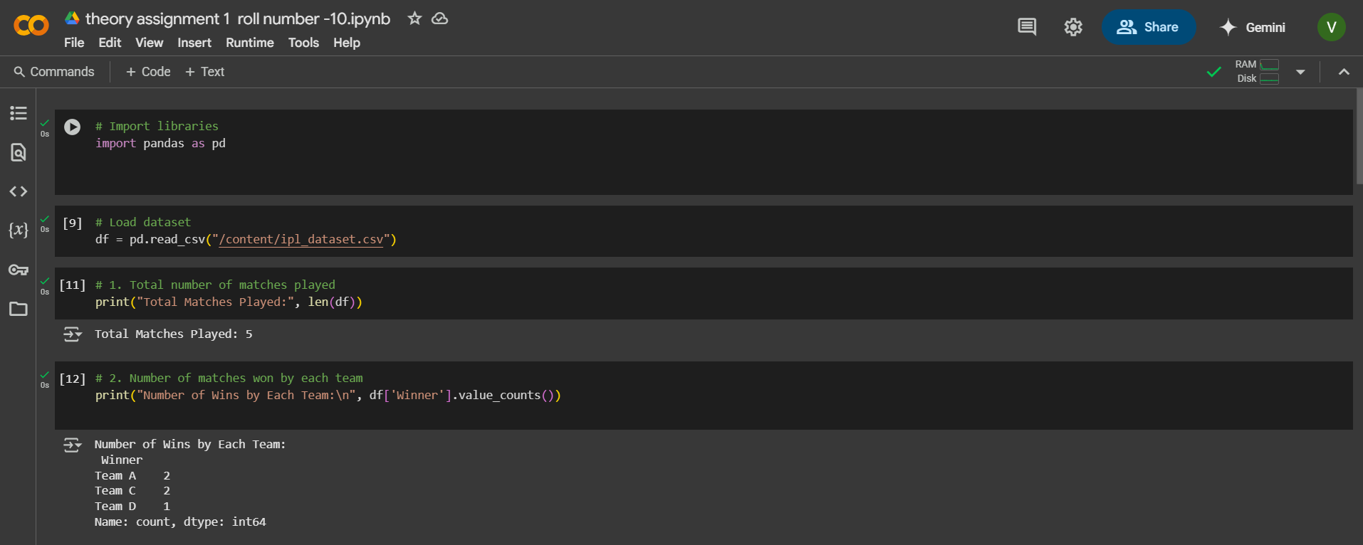

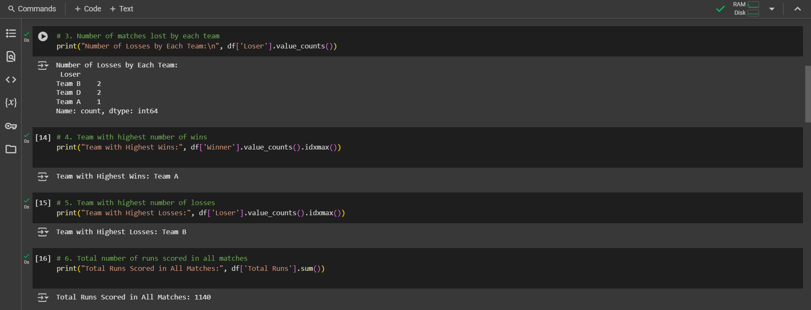

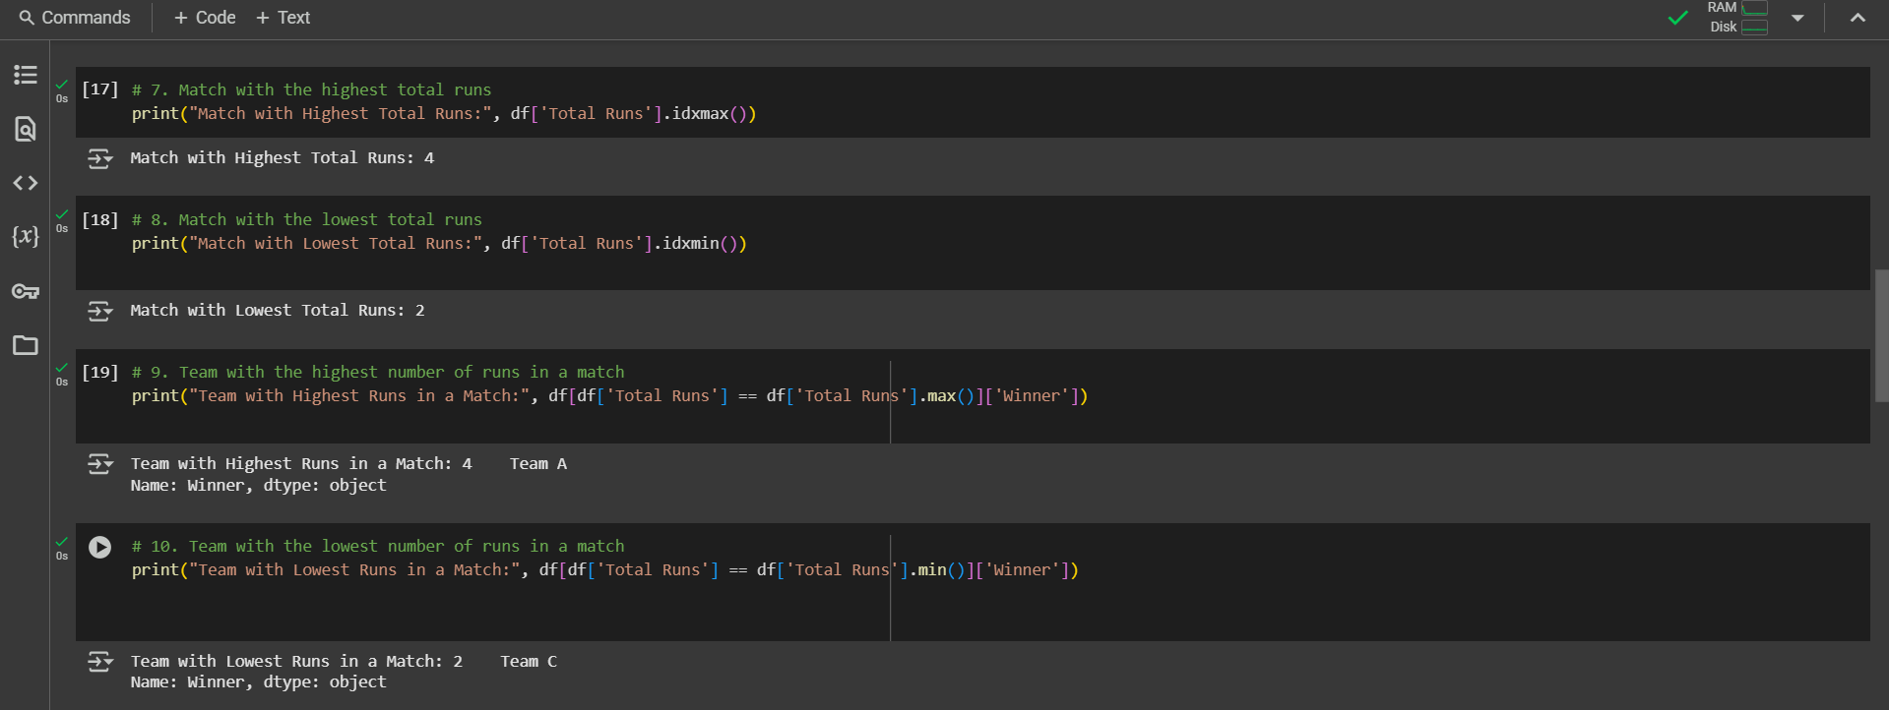

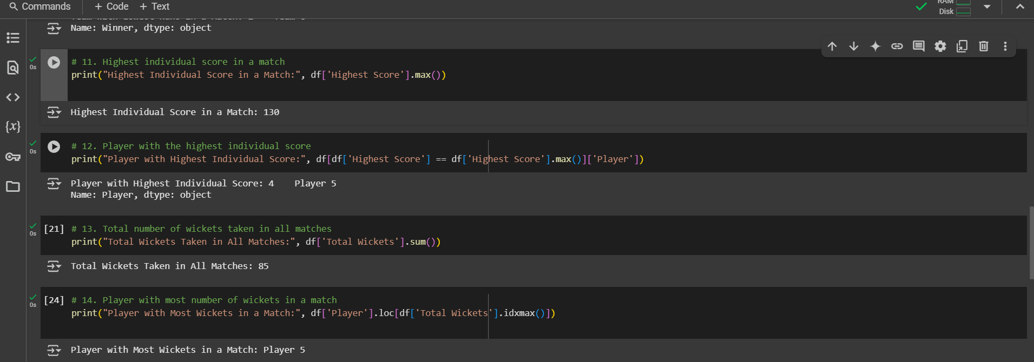



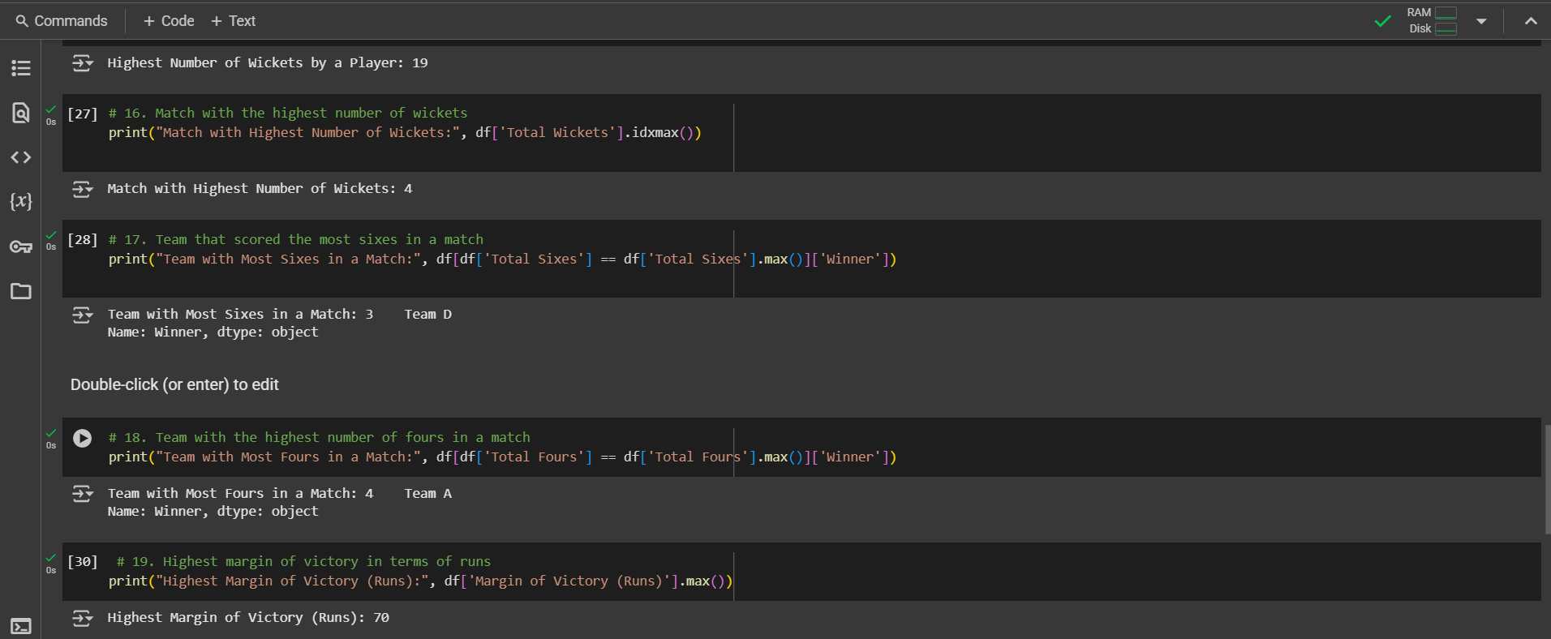

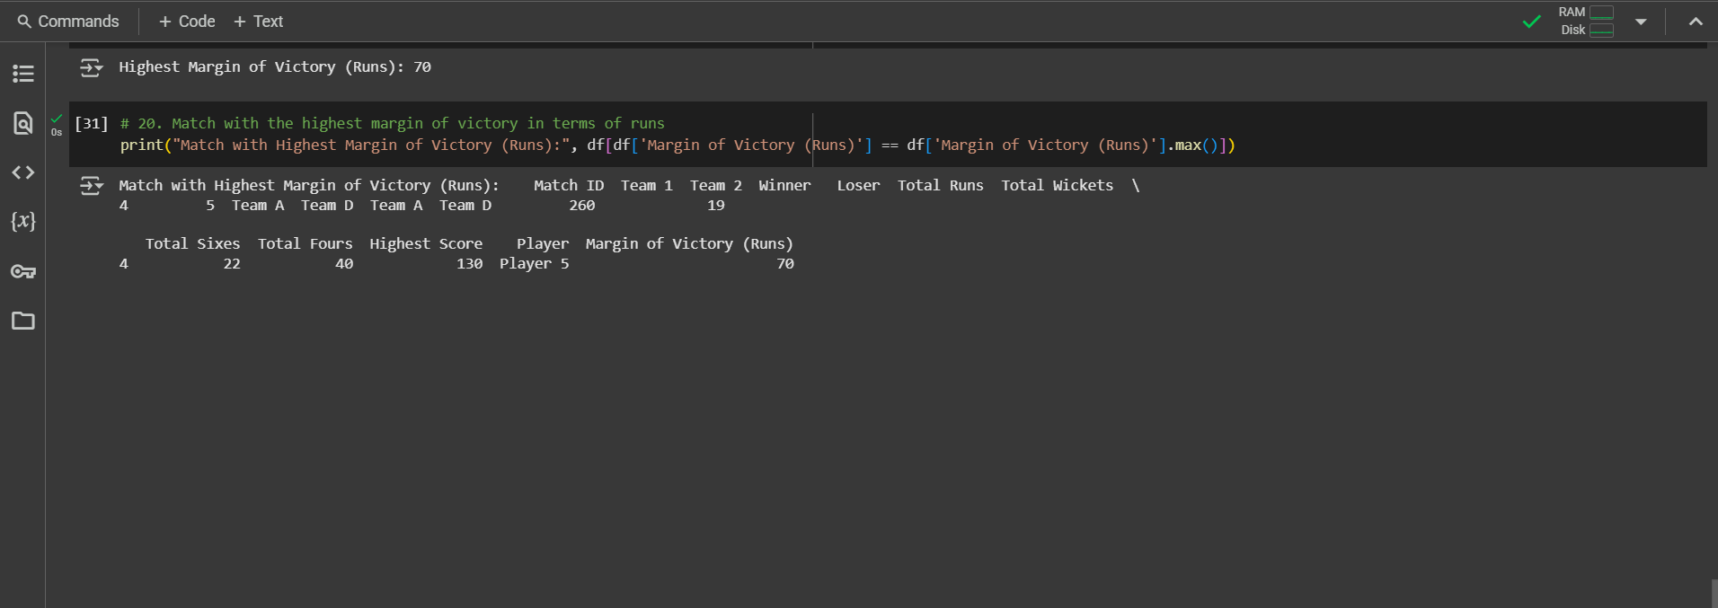

For sample data set used above, use the link given below:

<ipl_dataset.csv>

In case file not opend, I have attached screenshot of datatable.

